
RRTU GCF REF NUMBER:
Date received:
Rivers Run Through Us Community Grant Fund - pilot 2025/26
Application Form
For projects requesting contributions up to £5,000

1. APPLICANT DETAILS
Name (main contact)
Position in organisation
Daytime telephone number
Email
Group or organisation name
Address of the person dealing with the application (including postcode):
Website address (if one is available)

2. ORGANISATION STATUS (Please tick and complete all boxes that apply)
Voluntary organisation | ☐
Parish Council | ☐
Public Sector | ☐
Charity | ☐ | Charity number:
Private Individual | ☐
Registered Company | ☐ | Company number:
Other | ☐ | Please define:
Do you have a formal constitution | Yes ☐ | No  ☐
Are you VAT registered? | Yes  ☐ | No  ☐ | Vat Number:

3. PROJECT DETAILS
Project title (a catchy name that describes your project)
Project description – please include:
- A brief outline of your project and what you would like to spend the grant on
- Tell us what your project aims to achieve
- Who are the key people/organisations involved?
Timetable for your project  (all projects should be able to make a final claim by 31 March 2026) |  | Start date (month/year):
 |  | Completion date (month/year):
Other key dates that might be important for the project:

- PROJECT LOCATION
Please check your project is located within the Axe catchment? For this pilot we are looking to support projects located around Forton Brook and Kit Brook, including land in the Lower Axe catchment that is North of the main Lower Axe river.
Kit & Forton Brook area
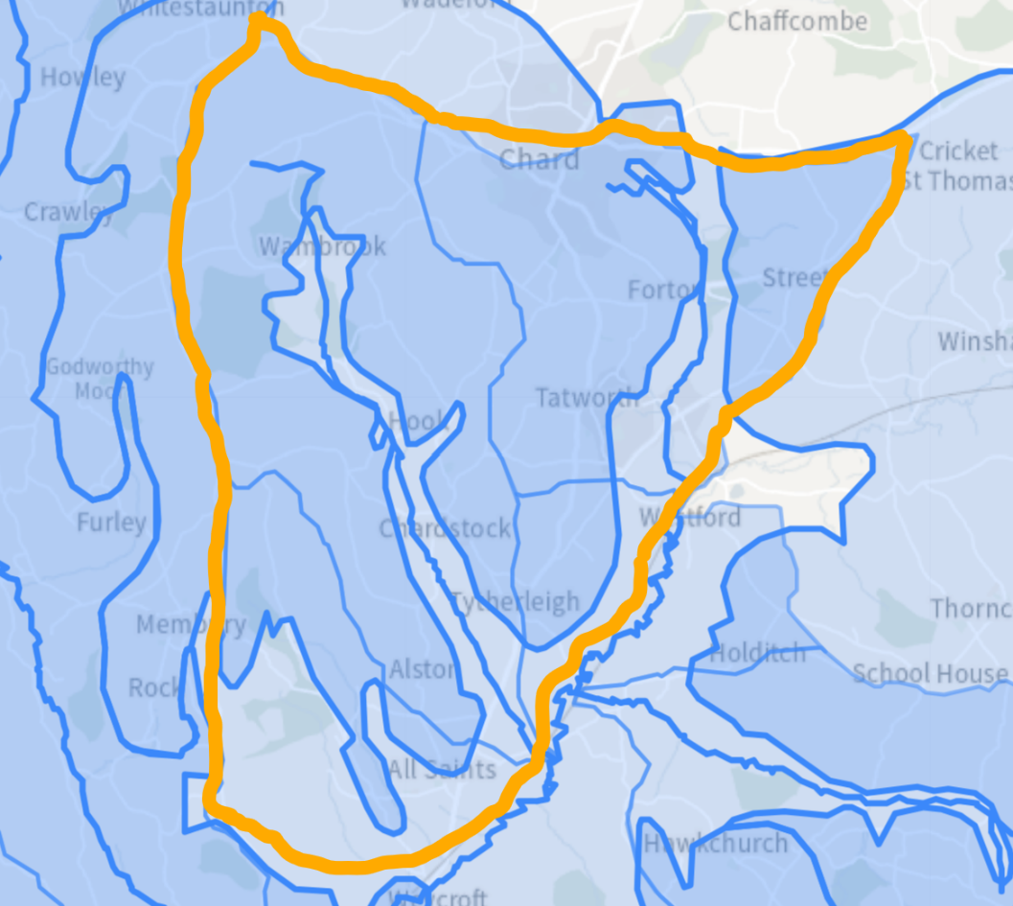
Rivers Run Through Us Project Area
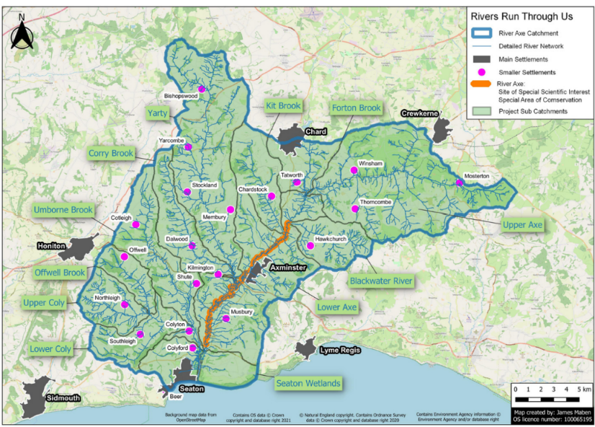

Who owns the land where the project will take place (if applicable)?
(Is there a lease? If so, how many years remain?)

Have you obtained all the permissions you require to carry out the project? (e.g. planning permission, written landowner’s consent, Local Authority or Environment Agency approval).

- PROJECT CHECKLIST – Rivers Run Through Us priorities
Your application will score more if it delivers one or more Rivers Run Through Us objectives. See RRTU Scoring Guidance Notes for Applicants for further help.
Please only complete the boxes below that are applicable to your project
WILL YOUR PROJECT? | HOW?
- Improve accessibility to the Forton Brook or Kit Brook, (physical, visual and/or educational)
- Increase understanding of the river catchment, ecology, geology, natural resources, heritage and/or catchment history
- Help to protect or promote one or both pilot Jewels of the Axe species, (Trout & Water Crowfoot)
- Carry out invasive species control (e.g. Himalayan Balsam)
- Undertake River Restoration to improve river morphology, (e.g. bank stabilisation, introduce woody debris, pool/riffle building, redd cleaning, planting)
- Provide Natural Flood Managment/ Nature Based Solutions to stabilise the river in its channel, reduce flash flooding and/ or increase water storage
- Carry out practical hands-on land-based projects where local people can contribute to taking care of wildlife habitats and improving water quality
- Help to support local community action
- Kickstart new partnerships between interested communities, (e.g. landowners, community groups, education providers)
- Encourage local people to develop a deeper connection with their local river
- Offer wellbeing and/or cultural activities that celebrate the river

- Offer new opportunities for volunteering and local participation

- DIRECT & COUNTABLE RESULTS - outputs of your project:
How many and what type of people, individuals, businesses, community groups, etc. will benefit from your project?
Estimated number of volunteers on the project and volunteer days on the project?
Countable achievements, e.g. trees planted, samples gathered, training sessions completed etc?
Other direct or countable results arising from your project?
Who will maintain the completed project and how will this be funded in the future?

- DECLARATION
I certify that all the information provided in this application is true to the best of my knowledge. I understand that any misleading statements, whether deliberate or accidental, could make the application invalid and therefore liable for the return of any money.

Signature:

Printed name: Date:

Please return the completed application form to:
Rivers Run Through Us, Riverside, Hemyock, Devon, EX15 3SH
or email to: RiversRunThroughUs@devoncc.onmicrosoft.com

