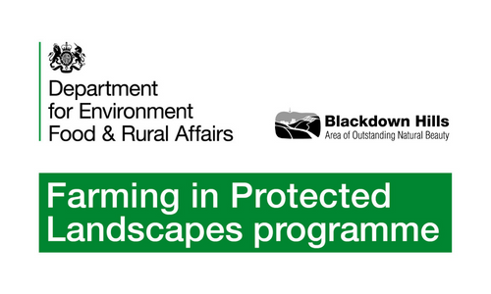
BLACKDOWN HILLS AONB

FIPL CASE STUDY

- GOREN FARM, STOCKLAND, NEAR HONITON

Overview

Goren Farm is a well-known supplier of high-quality wildflower seed, while its wildflower meadows provide an impressive visitor attraction during the summer months. Julian Pady, who runs Goren Farm, approached the Blackdown Hills FiPL team to discuss ways of meeting the growing interest in wildflower meadows amongst buyers and visitors.

Demand for locally-sourced wildflower seed is beginning to overtake supply, and Goren Farm recognise that new ways are needed to meet this demand, beyond what the farm itself can supply from its own land. Increasing numbers of landowners are wishing to restore traditional meadow flora on parts of their land, and meanwhile there is a need for existing flower-rich meadows and pastures to gain an economic value which can help pay for their management, as governmental agri-environment support payments go through an uncertain period of change.

Objectives of project

The demand for seed and the desire for economic return can be linked together, if seed from existing meadows can be harvested and made available to those who want it. Hence the project proposed:

- The purchase of a Brush Harvester, which will be hosted and maintained by Goren Farm and will be made available on loan to local landowners to harvest seed from their own land.

- The purchase of seed cleaning equipment, in the form of a set of Indented Cylinders, which will be used by Goren Farm to separate out seed of 8 key species from raw arisings gathered by the Brush Harvester, so that seed mixes can be designed to suit different soil types and conditions.

Meanwhile Goren Farm currently has no visitor facilities to cater for the people who come to experience the wildflower meadows on the farm. These include both paying customers and at least as many visitors coming to non-commercial open events like the National Garden Scheme open days. Hence the project further proposed:

- Creating a small all-weather parking area at the farm, and acquiring a tented structure which can be erected beside the car park in the summer months, containing visitor information and interpretation materials.

What is being done

1. A Logic MSH420 Brush Harvester has been acquired. This is a versatile, lightweight machine, towable behind a quad bike, ATV or small tractor, meaning it can be used on small sites with wet or uneven terrain. The harvester has a 1.2m working width and can be offset to allow collection from untracked foliage. It can be transported on a lightweight trailer.

Goren Farm have been using brush harvesters for 15 years now and can see the benefit of a small brush harvester that can be shared within the AONB. Their own harvesters are tractor-mounted and often too big to travel to uneven and remote sites by road. This facility will help the local community harvest their own locally native seed for local projects and be able to bring biodiversity benefits directly to the local area. The demand for wildflower and native grass seed is growing exponentially and if Goren can facilitate local farmers to harvest their own meadows before cutting or grazing this would help meet demand and deliver the objectives of agri-environment schemes.

The harvester will be made available on a not-for-profit hire basis between competent operators in the local area. It is proposed that when the machine is needed, one of these operators would be able to use the harvester (with their own pulling machine) either for themselves or on behalf of another landowner. A small daily fee will be charged for transport, cleaning, greasing maintenance and replacement parts and insurance. Instruction would be provided to operators and they would be asked to sign a hire agreement. The harvester will reside at Goren Farm when not in use.

Images: Logic Brush Harvester

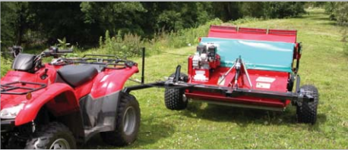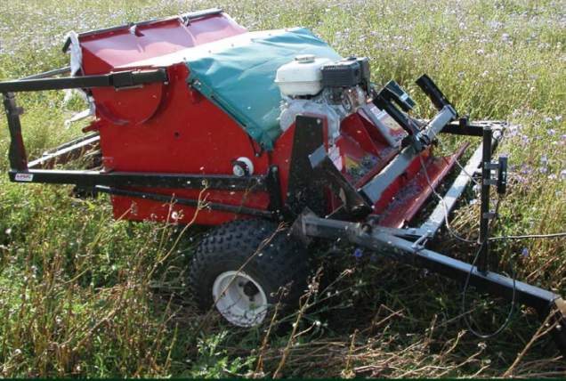

2. A seed-cleaning Indented Cylinder Separator has been acquired. This is a specialised machine comprising a rotating drum in which different cylinders are inserted, each with indents on the inside surface of a particular size. Material is introduced into the drum and seed of the desired size becomes trapped in the indents, while larger material passes through. The process both separates out the target seed, and cleans out the chaff, stems and other debris.

Having this machine will enable Goren Farm to extend its services to others (allowing local landowners to bring their meadow arisings to the farm and extract key meadow-creation species), while also allowing Goren itself to offer more pure-seed or specific multi-seed mixes to its customers. The machine will hence have both a commercial value, and a community value by enabling others to make the most of their meadows.

Images: Indented Cylinder Separator

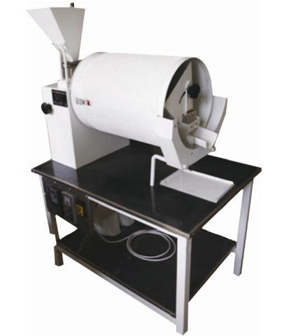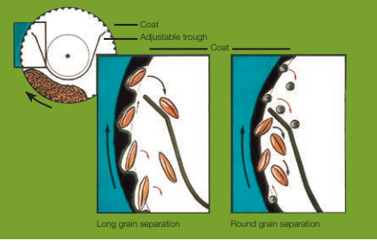

3. The visitor car park at Goren has been created with a gravelled space of 40m x 10m, for 12 cars, plus a grass-surfaced space for a further 12 cars. The car park is edged with oak sleepers with the gravelled area laid over a MOT Type 1 stone base.

For the visitor facility, a moveable, seasonal solution is being used, comprising a 10m by 12m stretch-canvas Tentickle cover on wooden poles. A rigid set of interior studwork ‘walls’ are to be placed under the canvas, on which interpretation and information will be attached.

Images: ‘Tentickle’ canvas moveable visitor facility, plan of visitor facilities

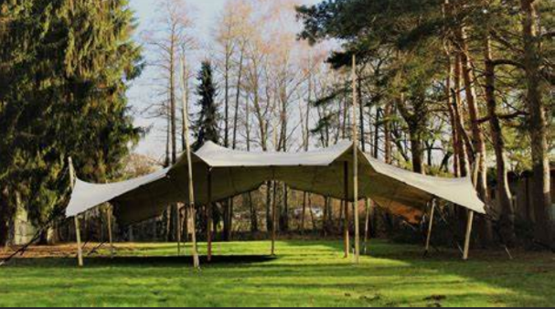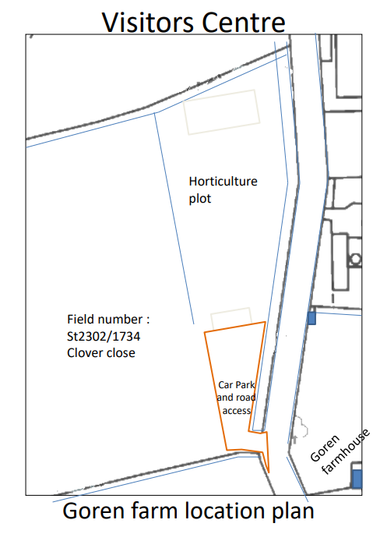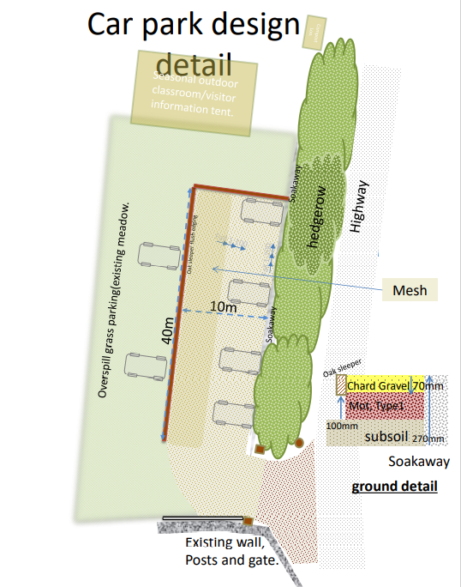

Costs

For the Brush Harvester, given this will be a community resource without specific commercial benefit a 100% grant was offered on a cost of £7095.

For the Indented Cylinder Separator, a 50% grant was offered towards a total cost of £5858.

For the visitor facilities, a 40% grant was offered towards total costs of £14,788.

Outputs/Outcomes

This investment by FiPL will provide a major boost to the ability of the Blackdown Hills landowning community to strengthen the local supply of wildflower seed to meet local demand. It will encourage collaborative working between landowners, while consolidating the role of Goren Farm as an exemplar in this field, supported by the AONB.

Learning points

The pre-existing Blackdown Hills Facilitation Fund network, and the close working relationship between farm conservation advisors in the AONB, were key ingredients in initiating the conversations which led to this project taking place. Those networks will continue to be key in enabling more landowners to harvest, exchange, and make use of high quality wildflower seed.

Gavin Saunders
FiPL Officer
Blackdown Hills AONB

March 2022

